Homegrown Trips: Desperate for PTSD Relief, Veterans Turn to Each Other for DIY Psychedelic Treatments

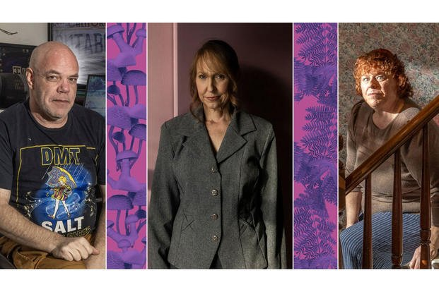
Photos by Greta Rybus, illustration by Hrisanthi Pickett of The War Horse
The War Horse | By Anne Marshall-Chalmers
Published February 13, 2025 at 10:20am ET
This story contains the topic of suicide. If you or anyone you know are having thoughts of suicide, please call 988.
Lena Ramsay lives with two aging chihuahuas—Diesel and Daisy—in rural Maine, down a long dirt road overlooking a glassy pond surrounded by layers of thick wilderness. It’s here, in her quiet 5-acre outpost, that she started feeling a lot better.
A deployment in Afghanistan left her with a traumatic brain injury, a shattered ankle, and a broken vertebra. Like many veterans, she obliged when VA doctors prescribed pain and sleep medication to help numb constant physical pain. But the antidepressants and sedatives she was also taking for PTSD, anxiety, and depression barely touched the gnawing anguish that would occasionally leave her unable to sleep, in a ball beneath her kitchen table.
Relief finally came after a friend extended a bribe: Try ayahuasca, and I’ll buy you margaritas after. When it was over, margaritas were the last thing on her mind.
Ramsay vomited and sweat through an emotional labyrinth that stretched for hours after drinking the hallucinogenic brew. Soon, though, she was consumed by how at peace she felt—reborn at 49. “There’s 10 years of therapy in one session,” she says. “It’s truly not a joke.”
Ramsay dove into psychedelics. She learned how to grow psilocybin mushrooms in her remote cabin in the woods. She brewed ayahuasca and vaped DMT, a hallucinogen extracted from plants. Ramsay knew all this was illegal, but the despair, once clamped like jaws, was loosening. She’d finally be OK, she believed, and it was such an incredible turn of events, that she could not keep it to herself, especially knowing so many other veterans were also suffering.
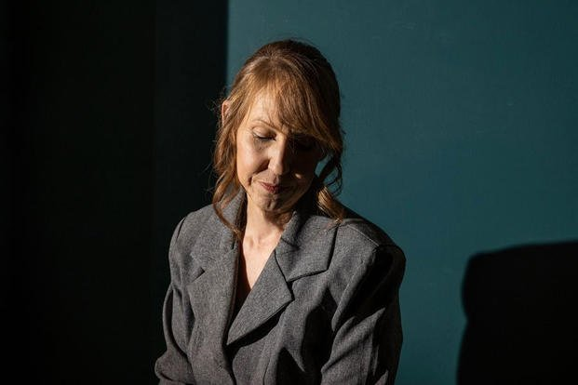
Lena Ramsay knows many veterans don’t want to attend organized psychedelic retreats, so she helped create a Facebook page for veterans to help one another learn how to access and use psychedelics on their own. (Photo by Greta Rybus for The War Horse)
So she partnered with another veteran to launch the Veterans Psychedelic Network, a Facebook group connecting veterans curious about psychedelics with veterans who know how to use, access, and grow or extract psychedelic substances.
Ramsay sees herself as a matchmaker, an educator, and while she thought her reach wouldn’t extend far past Maine, she was wrong. Over the last several months, The War Horse spoke with more than two dozen veterans, researchers, and advocates and discovered a growing movement of veterans from across the country taking healing into their own hands, and guiding one another through DIY psychedelic experiences, legal risks be damned.
With Ramsay’s help, for example, a young combat vet in Hawaii is now mentoring an Air Force veteran in her late 50s from Maine who is interested in cultivating her own psilocybin mushrooms. A former Army infantryman in the Pacific Northwest said he trusted a veteran he knew from his local Vet Center to teach him how to extract DMT into a smokable form.
A former Marine told The War Horse that he recently gave a stash of homegrown psilocybin mushrooms he had hidden in a Melatonin bottle—along with guidance on how to trip safely—to an Army veteran he met at a highway rest stop in New York. The two had struck up a conversation that ultimately led to the Army vet sharing his struggles with PTSD.
The budding DIY psychedelics network is bypassing more traditional or trendy treatments, such as overseas organized retreats where psychedelics are legal but can cost thousands of dollars and, some said, can feel a little too cult-like. Veterans desperate to feel better are also not interested in waiting for laws to change. So they’re looking to the community they know has their back.
“Veterans are attached to other veterans,” says Ramsay.

From ’60s Counterculture to Joe Rogan
Psychedelics, which include psilocybin, LSD, DMT, and MDMA, were once a darling of 1960s counterculture only to slip out of favor. But they have recaptured America’s attention with CEOs and celebrities chasing enlightenment through psychedelics, and some of the world’s most prestigious universities are studying their treatment for a variety of psychological disorders.
They are still classified as Schedule 1 drugs, meaning they are illegal, and the FDA is wary of their abuse risk. But psychedelics are also not a top priority for law enforcement. The internet is full of information about the mind-altering drugs, making psychedelic usage a thinly veiled underground endeavor.
The RAND Corporation estimated that just over 8 million U.S. adults used psilocybin in 2023. Some states, including Oregon and Colorado, and municipalities have legalized limited uses of psychedelic mushrooms, and the Supreme Court and another federal court have protected the rights of certain religious groups to offer psychedelics as a sacrament. Still, most people in the United States who take psychedelics legally are participating in one of the hundreds of clinical trials underway. Late last year, VA announced it was committing $1.5 million to study psychedelics as a treatment for post-traumatic stress disorder and alcoholism.
Most veterans tell The War Horse that podcasters Joe Rogan or Shawn Ryan, a former Navy Seal who hypes psychedelics’ benefits, sparked their curiosity. From there, veterans often find one another through Reddit, YouTube, and Facebook.
Eric Petersen, a member of Ramsay’s Veterans Psychedelic Network, posts online tutorials that explain how to concoct a smokable form of DMT with a few hardware store items and some free time. (YouTube took the video down over the summer, and he reposted it on Rumble.) Petersen, who served in the Air Force for a few months and works with many veterans, will often mentor them through a dosing ladder that eventually will get them to the big, revelatory trip many are chasing.
“A person trying to push something that’s an escape drug is going to be like, ‘Here—I don’t want to f------ see you until you need more. And that’s not what this is about,” he says. “Everybody gets a little bit of an education.”
Ramsay also looped in a veteran who goes by the alias Allen D’fungi. He asked that The War Horse use his alias out of fear of legal repercussions.
About three months ago, he created a Facebook page for veterans to learn the basics of cultivation. At 20 years old, in 2013, he was deployed to Forward Operating Base Shank in Afghanistan, aka “Rocket City” because of mortars that regularly rained down. At one point during his deployment, he wrote a letter to his parents saying that if he were killed, he’d die a proud soldier. He tucked the note into a pouch he made of duct tape that he hoped could survive a blast, gunshots, or whatever fate delivered.
Years later, psilocybin and meditation have helped him heal the anxiety and paranoia he carried back from deployment, he says.
With 17 veteran suicides per day, he feels helping veterans find healing through psychedelic experiences outweighs any potential legal risks. “If it even helps one person, it’s worth it.”
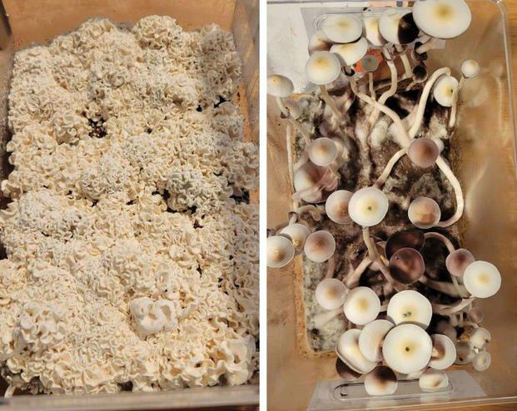
Two varieties of psychedelic mushrooms grown by “Allen D’fungi,” a pseudonym for a combat veteran who has found healing through psychedelics and now helps veterans learn to grow their own hallucinogenic mushrooms. (Photos by Allen D’fungi)
It’s impossible to know exactly how many veterans are engaging in DIY psychedelic treatment, but a recently published survey of 426 veterans found a little more than half had used psychedelics. Of those, 70% were doing so for healing purposes and about half reported that fellow veterans were their source for information. Far more chose to trip in their homes or the outdoors as opposed to a clinical setting or organized retreat.
Jesse Gould, founder and president of Heroic Hearts, a nonprofit that advocates for psychedelic research and helps pay for veterans to attend retreats in other countries, says he’s not surprised some veterans are choosing to become their own healers. He knows the interest is overwhelming—the waitlist for his retreats usually totals at least a few hundred, he says.
Gould says the country has historically fallen short in helping veterans who’ve endured significant trauma. Suicide rates in veteran and active-duty populations have risen for two decades. Research shows that up to 30% of veterans drop out of treatment offered by VA to address PTSD, and about half of veterans who try the therapies, including exposure therapy and eye movement desensitization, still have a PTSD diagnosis after they complete their sessions.
With that in mind, Gould, a former Army Ranger, views the veterans’ underground networks as concerning from legal and safety standpoints, but also noble. “It shows the ingenuity of veterans, and I celebrate that these people are trying to hold on to life,” he says, “and that they’re helping other veterans do that.”

Hitting Rock Bottom
In 2009, Ramsay was the mother of a 22-year-old daughter and a son who had recently turned 18 and announced he wanted to join the military. Ramsay, whose father briefly served in the Army, got the itch to serve too, a seemingly curveball move for a petite 38-year-old antique store owner living in suburban Colorado.
But she was always game for a challenge and had already hopped careers a number of times, from asbestos removal in her teens to a criminal investigator to an addiction counselor. The Army didn’t feel like an impossible leap, and her goal was to commission as an officer, paving the way for a secure future.
Ramsay’s son never made it to boot camp—but she did. And two years later, she was guarding detainees at Camp Sabalu-Harrison in Afghanistan as part of the Army’s 308th Military Police Company. Ramsay fully rewired into a war zone soldier, hypervigilant to stay alive one moment and cheating death the next—she recalls more than once taking long draws off her cigarette rather than scurrying to a bunker when alarms would scream of yet another incoming mortar. Only when a rocket was so close you could hear its high-pitched hiss did “you really have to move,” she recalls.
Guarding detainees delivered around-the-clock stress—riots, jail cells that failed to lock. On top of that, Ramsay’s command demanded extensive physical training, and she’d often run loops along the wire, her lungs burning from the acrid fumes of nearby burn pits. She’s since been diagnosed with COPD and asthma.
One day in 2011, while she was loading a large tactical truck with equipment, the truck’s driver hit the gas with her still in the truck bed. She flew out, shattering her ankle and smacking her back on the ground with such force that she still has pain to this day. She also sustained a traumatic brain injury.
Bret Maverick, who has known Ramsay since their childhood in Colorado Springs, recalls his friend coming back from Afghanistan as a totally different person. He watched his once caring, tenacious friend become incapacitated, and he recalls asking, “Would she be one of those soldiers who would’ve taken her own life?”
Most of the veterans interested in experimenting with psychedelics have already hit rock bottom, Ramsay and other veterans say. It’s a population that has cycled through traditional therapy and medications, and while many admit to having used drugs such as MDMA, aka “ecstasy,” to party while in uniform, they now refer to the substances as “sacraments” or “medicine.”
One veteran in Arizona joined the Veterans Psychedelic Network in hopes of muting his volatile temper. He connected with Petersen, who offered a few free vape pens loaded with DMT. Now, in addition to ongoing therapy, he relies on Petersen for a free once-monthly vape pen that he uses by himself, often by the pool in his yard.
“I don’t want to say like, ‘Oh well, it gets me high,’” he says. “I would consider it more of a mental recharge.”

Attracting Homeland Security
Psilocybin, ayahuasca, and DMT emerged as the most popular among DIY veterans who spoke with The War Horse.
DMT is extracted from Mimosa hostilis root bark and other plant materials and produces a short, intense trip. For that reason, Dr. Deepak D’Souza, a Yale professor of psychiatry who studies DMT’s potential benefits, says DMT-assisted therapy may one day offer a more feasible, cost-effective treatment for busy, understaffed VA clinics than other psychedelics that trigger long trips.
“To sit with someone for six to eight hours would be very, very challenging,” he says.
Despite the enthusiasm, the drugs carry safety and legal concerns, and VA has stated that while these substances show promise the agency does not “recommend psychedelics for use as part of a self-treatment program.”
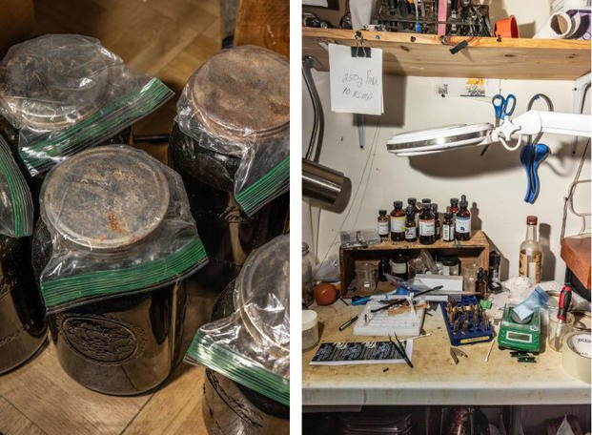
Left: As part of a multistep process, Eric Petersen relies on a liquid solution to extract DMT from Mimosa hostilis root bark. Right: Petersen’s workbench. (Photos by Greta Rybus for The War Horse)
Petersen, for instance, woke to a Homeland Security agent pounding on his door in Saco, Maine, in the dark, early morning hours of July 23, 2024. The agent had a search warrant to seize vape pens, bags of tree bark, jars—everything Petersen used to extract DMT.
He believes the agency caught on to him when it intercepted large quantities of Mimosa hostilis that he was importing from Mexico. The agent advised him to stop importing so much bark, and no charges have been filed. But Petersen isn’t one to lay low, often outfitting himself in “I Make DMT” shirts and hats he designs.
Not surprisingly, the increased popularity and use of psychedelics has led to a rise in the number of hallucinogen-related emergency room visits in the U.S., even though psychedelics are considered far safer than most other Schedule 1 substances, like heroin or meth. Still, they can elevate heart rate and cause prolonged psychosis for people with a history of schizophrenia and bipolar disorder.
In late 2023, in San Francisco, a veteran who served in Afghanistan took three times the amount of psilocybin he typically microdosed, according to court records. He wound up in a psychotic state, naked in the street, and shooting a gun. While no one was hurt, the veteran wound up facing felony firearm charges. His case has been diverted to veterans court, and if he complies with court-ordered treatment, the charges may be dropped.
That kind of dramatic side effect is rare. And many veterans say they dig into research before trying psychedelics. Many also arrange to have a “trip sitter,” or someone who ensures they do not harm themselves or others. In the survey of 426 veterans, researchers were surprised to find that even when trips proved emotionally and physically challenging, most veterans still reported a positive experience.
One veteran in the Pacific Northwest who spoke to The War Horse wept as he recollected his radical transformation.
He served in the Army for seven years and requested anonymity because he works in the mental health field and feared his psychedelic use might taint his professional reputation. He said in an interview that on Nov. 10, 2004, during the second Battle of Fallujah, as his unit cleared buildings, he “executed” an Iraqi civilian in the man’s home. When he discovered the man was carrying a list of family contacts, he knew a family would be shattered by grief.
The veteran was racked with post-traumatic stress, depression, and suicidal thoughts for years, even winding up at a PTSD specialty clinic at the VA Hospital in Palo Alto, California. Therapists told him repeatedly to recognize the chaos in Fallujah led to his actions. Nothing helped, he said.
Several years ago, he decided to ingest a large dose of psilocybin mushrooms in the woods with his wife as his “trip sitter,” and he has since also used DMT. Through these experiences, he said, a switch flipped, and once-persistent self-loathing has retreated.
“I can love myself,” he says, recalling that memory from November 2004 through tears. “I wish it wouldn’t have happened, but it did.”

Sci-Fi Splendor, Faceless Mother Figures
Veterans shared with The War Horse that during hallucinogenic trips, universal truths that everyone knows, but tend to diminish, somehow stuck—love is paramount, let go of the small things, forgive yourself. They describe their trips in sci-fi splendor, recounting planet-sized creatures delivering wise comfort, faceless mother figures composed of beads of light, and trees that emoted warmth and community.
It’s not uncommon for traditional treatment to fail those deeply stunned by war and their part in it, says Dr. Harold Kudler, a Duke University associate professor in psychiatry and a retired VA psychiatrist.
“There is, in times of great distress, or after trauma, a need to connect with something beyond ourselves,” he says. “Because the trauma itself opened up a world that seemed beyond us, and we’re drowning in it.”
A few years ago, Cecelia Corey could barely hang on. Some nights she secretly hoped death might strike her as she slept. The Air Force veteran in her 50s had watched a show about the promise of psychedelics for healing, and in 2023 she messaged the Veterans Psychedelic Network for guidance.
Corey also lives in Maine, a rural, older state that may not pop to mind as hot on psychedelics like California or Colorado. But Portland, Maine’s largest city, is among many urban areas across the country that have softened on arresting or charging individuals who use psychedelics.
Corey also does not align with who one might expect in the psychedelics space. She’s a grandmother with a short curly hairstyle and animal-print TJ Maxx reading glasses. Nightly ice cream is her weakness.
But she has not had an easy life. In the ’80s, she left behind a difficult childhood to join the Air Force. One night, during a barracks party, she was drinking orange juice and vodka with a young airman she liked, when she blacked out, perhaps from a drug slipped into her drink. The airman raped her.
Decades later, in November 2019, she suffered an immeasurable loss. Corey asked police to check on her adult son who hadn’t been heard from in days. When they arrived, her son ran to a bathroom and shot himself. Police found his girlfriend stabbed to death, an unfathomably tragic end to a volatile relationship. Corey was bereft but had no time to grieve. Her six-month-old grandson was now orphaned, and, in their 50s, Corey and her husband agreed to become his adoptive parents.
Her deep sadness, coupled with the COVID pandemic shutdown and the care of a baby who had many health problems, culminated in a severe nervous breakdown in the winter of 2022. She wound up at a VA psychiatric facility in Pennsylvania for two months.
While it helped, sometimes, she says, she’d still have to drive to the middle of the woods and scream, “just to get the horror out of me.”
In December 2023, she wound up back in a VA psychiatric hospital for five days. Corey says she asked her VA doctors to refer her to a ketamine clinic. Ketamine-assisted therapy is the only federally approved drug-assisted therapy. Though not a classical psychedelic, ketamine can cause hallucinations and has a sedative effect, which can help people open up in therapy.
But Corey says VA wouldn’t let her try ketamine until she had exhausted other treatment options. She’d already tried a number of different types of therapy, she says, and didn’t like antidepressants that turned her into a semi-emotional zombie. So she started her own search for psychedelics and found Ramsay and the Veterans Psychedelic Network.
Corey’s only been using psychedelics, including MDMA, ayahuasca, and DMT, for less than a year, but, like many other veterans with whom The War Horse spoke, she’s a true believer. “The wonder of psychedelics,” she says, is decades of treatment-resistant depression “just unspooled in front of me.”

Spirit Molecule or Super Placebo
Evidence of bias and evangelism have plagued psychedelic research and even contributed to the FDA’s recent denial of MDMA-assisted therapy for PTSD. Had it been approved, the therapy would’ve been the first new treatment for PTSD in decades.
The FDA denial was a blow to advocates, but research into the medical use of psychedelics continues. In December, VA announced it was funding research on MDMA-assisted therapy for PTSD and alcohol use disorder. Though this would mark the first VA-funded psychedelics research since the 1960s, the military and VA have long wrestled with how to treat psychologically wounded soldiers.
An Army documentary from 1946, for example, explored hypnosis. Filmmakers followed soldiers who had developed ailments, including severe stutters and an inability to walk after their combat deployment in World War II.
After hypnosis, one servicemember who had to be carried into his session stood up and took steps like a wobbly foal, a large grin breaking across his face. The narrator advised that his milestone doesn’t mean his “neuroses” are gone, but “the way has been opened for the therapy to follow.”
Researchers have shown that psychedelics create new and more complex connections between neurons, essentially rewiring the brain, and perhaps opening the mind to new ways of thinking. But Dr. Rick Strassman, a psychiatrist and prominent figure in psychedelic research, says it’s still not clear why these changes in the brain “translate into benefit.”
Psychoactive substances only work with memories and thoughts already in the mind. “You might make associations that you hadn’t made before,” he says. “You might experience feelings that you’ve been pushing away previously.” But nothing new is planted, and often a person’s environment, expectations, and surroundings can influence the experience.
At one point in his career, Strassman likened DMT to the spirit molecule, or a substance that provided a transformative, powerful mystical experience. He has, however, shifted his perspective. “My theory is that psychedelics are super placebos,” he says. “That’s the reason that they seem to do everything for everyone, all of the time.”
Even if that’s the case, some researchers say, that doesn’t mean psychedelics should be dismissed. After all, a parent kissing their child’s bruised knee doesn’t stop the pain, but it does something.
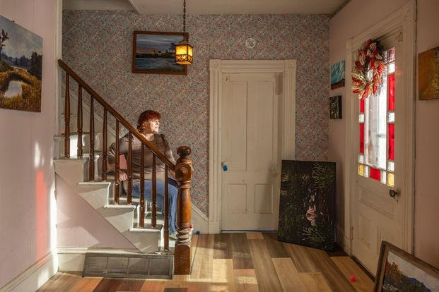
Cecelia Corey, at her home in central Maine, credits psychedelic experiences for unraveling and healing decades of treatment-resistant depression and PTSD. (Photo by Greta Rybus for The War Horse)
After nearly seven years of using psychedelics and diligently going to therapy, Ramsay has decided her psychedelic journey is fairly complete, and she’s scaled back her own usage significantly. She feels more like herself than she has in years, she says, and that’s been her goal all along. Her friend, Bret Maverick, sees the difference. “She’s about 90% back to the person she was prior to the military,” he says.
Ramsay says psychedelics, particularly ayahuasca, have even helped reduce her back pain to a manageable level for months at a time. She’s among a chorus of veterans who have been prominent in the push for legalization of psychedelics, both at the federal and state levels, and she’s hopeful that the Trump administration may take action. In October, Trump’s pick for the head of Health and Human Services, Robert F. Kennedy Jr., posted on X that “FDA’s war on public health is about to end. This includes its aggressive suppression of psychedelics.”
In late August, as Maine’s summer began to give way to the chill of fall, Corey and Ramsay were driving through Portland to meet with another veteran. The two women have become close over the last year, and Ramsay was by Corey’s side during Corey’s first ayahuasca ceremony this past summer.
In the car, psychedelics dominated the conversation—from how different substances crack open the heart and mind to the vast assortment of mushrooms growing wild in Maine. Soon, their chatter veered into the risks of their DIY psychedelic treatments, and how their indelible pain has shaped how they view those risks.
Ramsay said she’s known people who have emerged from psychedelic trips retraumatized and broken.
“The thing is, though, when you’re at the bottom, are you willing to roll those dice?” she said. “I was.”
“I was too,” Corey said as the late afternoon glow streamed through the car windows. “I’ve been through about the worst thing I could possibly imagine happening. I’m not afraid of anything anymore, and I don’t care.
“All I want is some relief.”

